PREPARATION SHEET LAB 01
SAMPLING AND QUANTIZATION
 | Team members
 | 1 | Efe Kardes
1/1 | 2 | Emir Avni Sahin
1/1 | 3

Please fill out the document electronically – including the yellow fields above – and upload it to Moodle once per team by the start of the lab event (no matter who uploads it, it will automatically be assigned to all members).
Please note that the complete lab assignment can be found in another document.

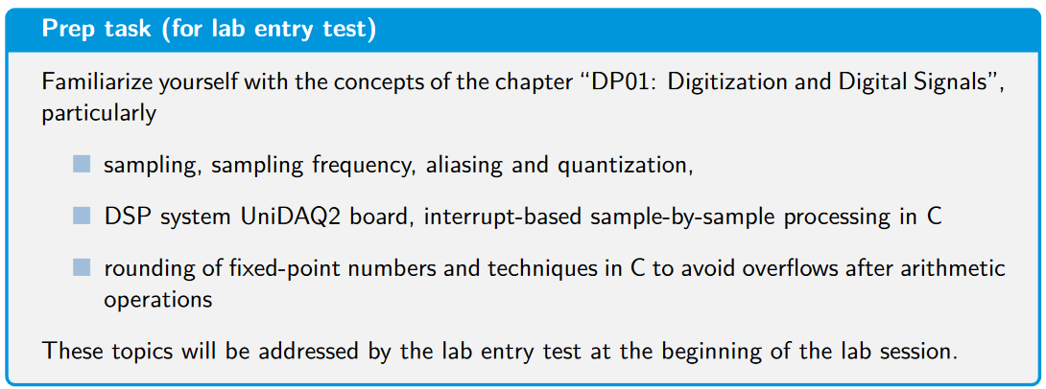

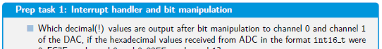
- Channel 0: 0x5455 in hex, 21589 in decimal
- Channel 1: 0x80CC in hex, -32564 in decimal

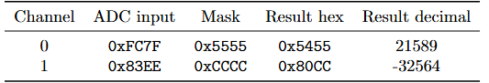

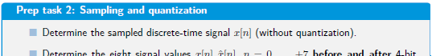
- sampled discrete-time signal: 1, 0.7071, 0, -0.7071, -1, -.0.7071, 0, 0.7071
- sampled and quantized signal: 0.875, 0.625, 0, -0.750, -1, -0.750, 0, 0.625
